Département Technique IESN

BAC3

Anglais Renforcement

2023-24



Chapter 2: Workplace Culture

Part 1: Cultural Etiquette

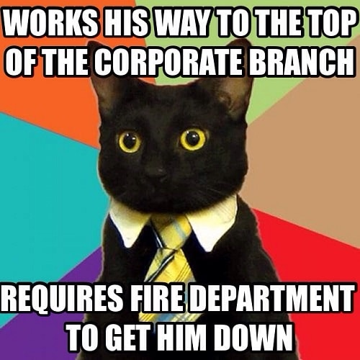

*Justine De Witte Stéphanie Hayen Ophélie Kruyts*

1. **The Cultural Etiquette**

**What is the cultural etiquette?**

**In the workplace : how to act at work depending on the country (linked with cultural difference)**

1. **Let’s play a Kahoot game to see what you know about cultural etiquette!**

**Type « Kahoot! » in you search engine.**

1. Click « Play »
2. Wait for the pin code of the game (your teacher will display the Kahoot screen to play). Type the pin code
3. Type your name
4. Ready, steady… play!

* To burp = rotter (In China it is acceptable)
* Remove your shoes in Japan
* No cappuccino after a meal in Italy
* Over apologizing typical GB
* Slurping your noodles is acceptable in Japan
* Asking for a doggy bag is rude in France
* Covering shoulders and knees in the Middle East
* Looking someone in the eyes is rude in Mexico
* Spitting on the bride is OK in Greece
* Hanging out in cemeteries is common in Denmark
* Reverse nodding is typical of Bulgaria
* The V sign is rude in the UK
* No thumbs up in Russia Greece Iran Sardinia and parts of west Africa
* Tip between 10-20% in the US
* The OK gesture is not OK in turkey
* Kissing on the cheek the first time you meet someone in spain
* Rude to eat everything on your plate in China
* No food finger in Chile
* No hand shaking in the doorway in Russia
* Wait for the other person to start eating korea

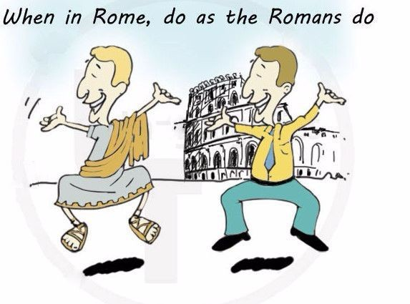

1. Discussion
2. ~~Did you know all the facts presented in this game?~~
3. ~~Can you give other examples?~~
4. What does the idiom (=expression idiomatique) « When in Rome, do as the Romans do » mean?

* Adapting to the cultural etiquette of a specific country
* E.g. cheek kisses several depending on the French region

1. ~~When you go abroad, do you check the local habits and customs before departure? Is it important to do so?~~
2. ~~What is the most difficult when you leave your country?~~
3. ~~How would you define the word ‘culture’?~~
4. ~~What are the elements that define a culture?~~
5. ~~Have you ever experienced any weird situation while being in another country?~~
6. ~~So, in conclusion, what do you really need when you go abroad?~~

***“A great way to learn about your country is to leave it”***

***Henry Rollins***

1. Small Talk[1]
   1. What is « small talk » according to you?

* “une petite discussion” = talking about the weather, etc
* Why ? if not it may become awkward + leave blanks in the conversation.
* Small talk is always present in the work place before a meeting and after it
* It provides a feeling of reassurance/warmth that’s much needed in the workplace
  1. What should you avoid while practicing « small talk »?
* Just like when you’re at a Christmas diner you should avoide everything that’s politics religion 🡪 touchy topics
  1. Can you think of advice to practise « good » small talk?
* You can’t really train you do it on a daily basis without even realizing it it’s innate.

**~~Exercise. Play the situations using small talk and the correct greetings:~~**

**~~Exemple 1~~** ~~: Je commence par demander à mon interlocuteur depuis quand il travaille dans l’entreprise, quelle y est sa fonction, puis son parcours, sa formation, le lieu où il a étudié, s’il se plaît là où il vit actuellement, quels loisirs il profite d’y pratiquer.~~

**~~Exemple 2~~** ~~: J’attaque le small talk par une question sur la taille de l’entreprise et j’enchaîne en demandant ce qui a attiré mon interlocuteur vers son poste, sa fonction, son produit. Je lui demande alors s’il arrive à faire cohabiter ses impératifs professionnels avec sa vie privée. J’en profite ensuite pour lui demander quelles activités il pratique pendant son temps libre.~~

1. **The Business Etiquette**
2. What is business etiquette?

* It’s cultural etiquette but in the workplace

1. How culturally aware are you? Try the following questionnaire.
2. You should stay just enough for him not to be vexed(offended) by you rushing 🡪 leave a door open
3. Knowing what British culture is like it’s better to let him finish and not intervene
4. To mingle = socializer 🡪 instead of having coffee at opposite ends of a room both teams could have a coffee together 🡪 smooth the negotiation
5. You shouldn’t slip away 🡪 in the US corporate world is central.
6. Maybe it’s a cultural thing 🡪 explain you’re nervous and you’ll do it (transparency).

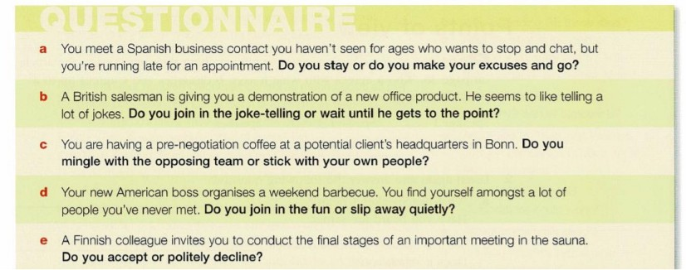

1. ~~Do you think that cultural differences play an important role in business? How?~~
2. ~~Which elements might cause problems during business relations?~~
3. How important are these things when doing business in your country? Are they a) important, b) not important or c) best avoided?
   * exchanging business cards: A
   * shaking hands: A
   * bowing: C
   * kissing: B
   * socializing with contacts: A
   * small talk before meetings: A
   * accepting interruption: B
   * giving presents: B
   * being direct: B
   * using first names: B
   * being formal or informal: A
   * punctuality: A
   * humour: B
   * eye contact: A
4. Vocabulary

end eye eye fire foot ice water water

**1. Complete the idioms in the sentences below with the words in the box.**

1. Small talk is one way to break the Ice when meeting someone for the first time.
2. I was thrown in at the deep End when my company sent me to run the German office. I was only given two days’ notice to get everything ready.
3. We don’t see eye to Eye with our US parent company about punctuality. We have very different ideas about what being ‘on time’ means. It’s a question of culture.
4. I got into hot water with my boss for wearing casual clothes to the meeting with the potential Japanese customers.
5. I really put my foot in it when I met our Spanish partner. Because I was nervous, I said ‘Who are you?’ rather than ‘How are you?’.
6. I get on like a house on fire with our Polish agent; we like the same things and have the same sense of humour.
7. When I visited China for the first time, I was like a fish out of water. Everything was so different, and I couldn’t read any of the signs!
8. My first meeting with our overseas clients was a real eye-opener. I hadn’t seen that style of negotiation before.
9. Match the idioms in exercise 1 to the correct meaning.

* given a difficult job to do without preparation: B
* quickly have a friendly relationship with someone: F
* feel uncomfortable in an unfamiliar situation: G
* say or do something without thinking carefully, so that you embarrass or upset someone: E
* disagree with someone: C
* an experience where you learn something surprising or something you did not know before: H
* make someone you have met less nervous and more willing to talk: A
* get into trouble: D
* It’s raining cats and dogs = it’s raining hard
* To hit the hay = to relax /nap
* I’m all ears = I’m listening
* When pigs Fly = when something will never happen
* To tie the knot = get married
* To bite off more than you can chew = take on more than you can handle
* To be a couch potato = being lazy
* A piece of cake = easy
* To miss the boat = miss your opportunity
* Once In a blue moon = rarely
* To let someone off the hook = free from a task
* You’re the apple of my eye = my favorite person
* To hit the nail on thee head (you’re right (nailed it)
* Back to the drawing board = try again
* Back to square one = //
* The ball is in your court = it’s time for you to decide

1. Project: oral exercise

Alone or with a partner, choose a country (not twice the same country in the classroom). Look for information about this country basing yourself on the questions here below, in order to present the business etiquette of this country to your colleagues.

* + Prepare a short presentation about the business culture of the country you have been given.
  + Make some research in order to learn about your country’s business etiquette.
  + Consider the different topics you can find here below and use the list of questions to structure your talk.
  + Be ready to answer questions.
  + Your presentation should last about five minutes.

Facts to gather about your country:

*Appearance*

How do men and women dress in business?

Is casual dress permitted in business meetings?

How do people dress on social occasions, e.g. at an informal dinner?

*Behaviour*

Do people like a lot of personal space?

Do they usually stand close or far away from another person when talking to colleagues? Do staff use first or family names when addressing each other?

*Entertainment*

Do businesspeople prefer to entertain guests at home or in a restaurant? What advice can you give about gifts?

What are good/bad topics of conversation?

*Meetings*

How important is punctuality in that culture? Is a person’s status important in meetings?

Is decision-making slow or fast in business?

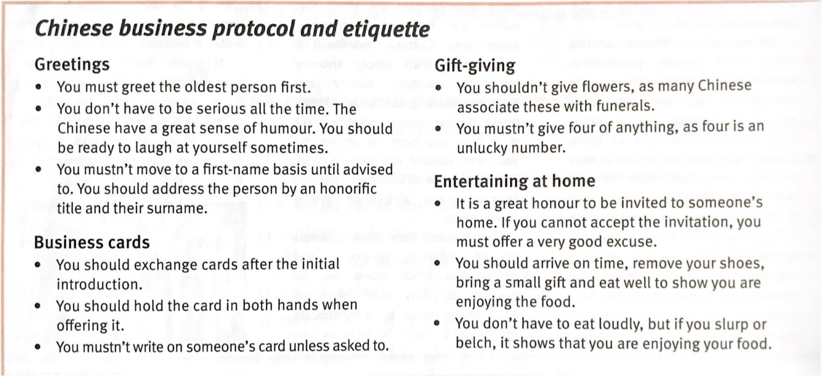

N. B.:

Even if your company **isn't international**, your workforce or your customers may have **roots** in different cultures. Learning to master **different cultural etiquette and protocol** can go a long way toward making **a good first impression,** second impression and all the impressions after that. Your team should practice the same principles.

**Learn languages**. Even **a few key phrases** may help create **a good first impression**. If you're dealing with one particular culture, such as Indian or Israeli, make an effort to learn more of their language.

**Encourage employees to be open-minded**. If your team includes people from different cultures, encourage them to **share their perspectives**. Remind your employees that you want them to be accepting of each others' differences, not intolerant.

**Try new things.** Have lunch with a client or employee and try their cuisine, whether it's Ethiopian, Korean or kosher. Don't compromise your principles - don't eat meat when you're vegan - but if you're comfortable experimenting, you can create a good first impression.

**Accommodate differences**. Jews and Muslims, for example, have different holy days from Christians. They have food restrictions, such as not eating pork. Scheduling mandatory corporate training on Yom Kippur or buying your team pork tacos, with no alternative, for lunch makes you look clueless.

**Treat people as individuals.** Don't assume that every Brit or Korean or Mexican conforms to the same type or follows the same etiquette. There's no such thing as a generic Swede or Mexican or American. People are as individual as their fingerprints. [2]

*Credits: Stéphanie Hayen 21-22, Hélène Briamont 20-21*

1. [https://www.plussept.com/blog/small-talk-technique-pour-mieux-compr](http://www.plussept.com/blog/small-talk-technique-pour-mieux-comprendre-interlocuteur/)endr[e-interlocuteur/](http://www.plussept.com/blog/small-talk-technique-pour-mieux-comprendre-interlocuteur/)
2. https://smallbusiness.chron.com/cross-cultural-business-etiquette-2907.html